Experiment 10

Structured Chart

Software engineering

Introduction

Structure Chart represent hierarchical structure of modules. It breaks down the entire system into lowest functional modules, describe functions and sub-functions of each module of a system to a greater detail. Structure Chart partitions the system into black boxes (functionality of the system is known to the users, but inner details are unknown). Inputs are given to the black boxes and appropriate outputs are generated.

Modules at top level called modules at low level. Components are read from top to bottom and left to right. When a module calls another, it views the called module as black box, passing required parameters and receiving results.

# Symbols used in construction of Structured Chart

1. Module

It represents the process or task of the system. It is of three types.

* Control Module-A control module branches to more than one sub module.
* Sub Module-Sub Module is a module which is the part (Child) of another module.
* Library Module-Library Module are reusable and invokable from any module.

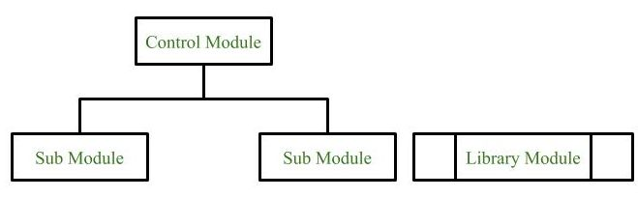

1. Loop

It represents the repetitive execution of module by the sub module.

A curved arrow represents loop in the module.

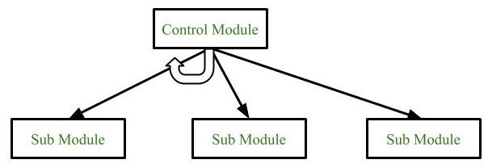

1. Data Flow

It represents the flow of data between the modules. It is represented by directed arrow with empty circle at the end.

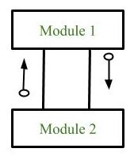

1. Control Flow

It represents the flow of control between the modules. It is represented by directed arrow with filled circle at the end.

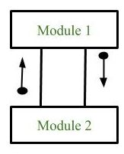

1. Decision

It represents that control module can select any of the sub module based on some condition.

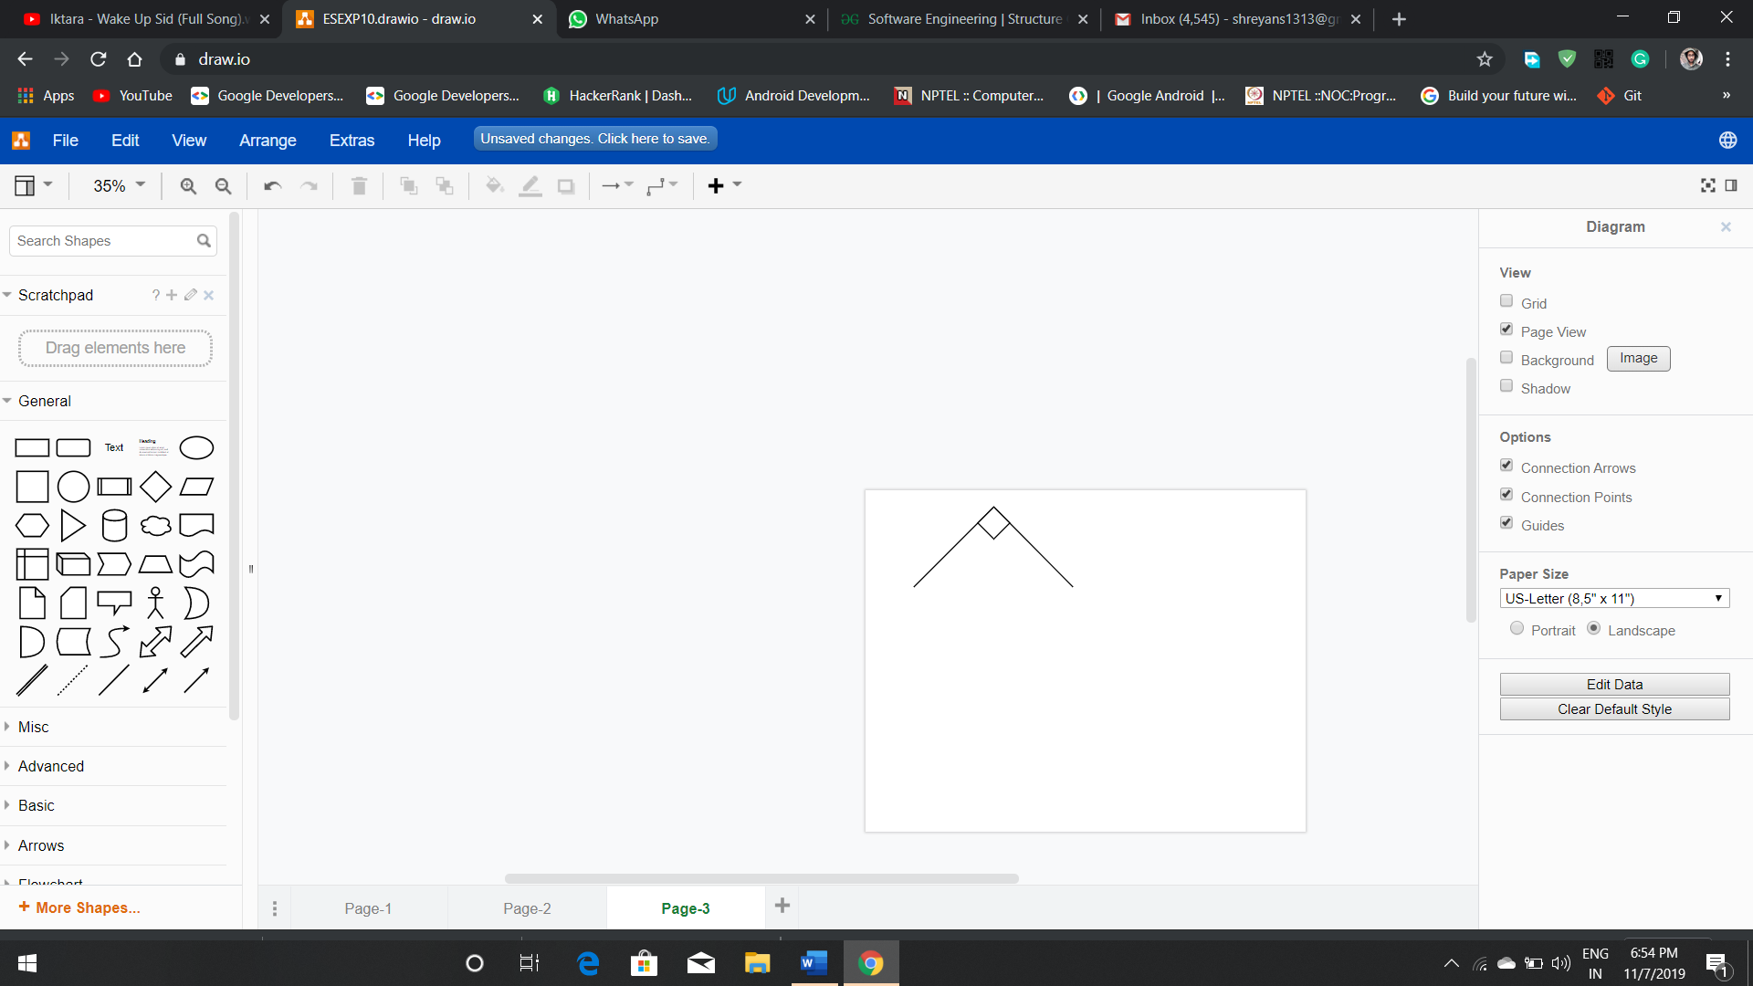

# Types of Structure Chart

Transform Centered Structured:

1. This type of structure chart is designed for the systems that receives an input which is transformed by a sequence of operations being carried out by one module.
2. Transaction Centered Structure:

These structures describe a system that processes several different types of transaction.

# STRUCTURED CHART

